QBUS5001
Q&A Lecture notes - Week 10

Part 0 – Administrative matters

0.1 Group assignment is available now
Your group assignment will be available on 2:05pm 08/10/2024 via the link:
https://canvas.sydney.edu.au/courses/61229/assignments/549695

0.2 Nomination for Students' Choice Award for Teaching (Deadline 1 November 2024)
If you’ve found my teaching helpful, I would greatly appreciate your nomination for the Students' Choice Award for Teaching. This would not only benefit me but also help show others how unique and engaging a university classroom can be.

The nomination link is attached below:
https://forms-business.sydney.edu.au/teaching/students-choice-award-for-teaching

Here are the details you need to submit your nomination:

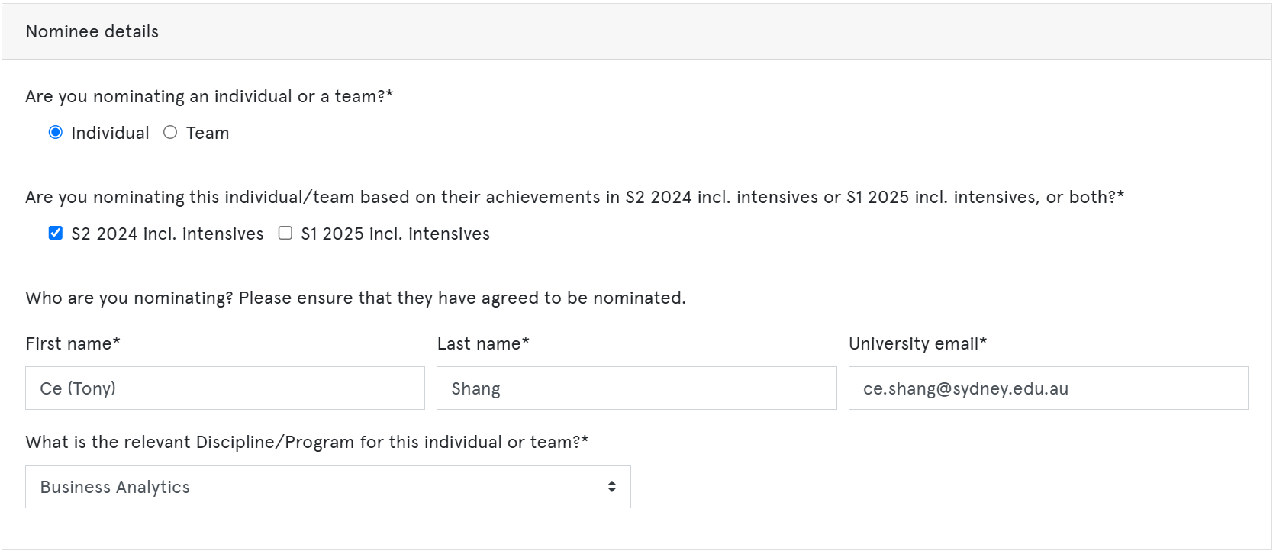

0.3 Nomination for 'Wayne Lonergan Award for Outstanding Leadership in Teaching' (Deadline 1 November 2024)
There’s another award, the Wayne Lonergan Award for Outstanding Leadership in Teaching, which also aligns with my work. It seems more complex, but if you feel I’m deserving, I’d love to give it a shot!
Here’s the nomination link:
https://forms-business.sydney.edu.au/teaching/WLOT-nominations
The same details are needed for the nomination:


I truly appreciate your time and effort in the nomination process. Thank you in advance!

I truly believe we are witnessing history together! I never imagined things would unfold in such an incredible way, and none of this would be possible without your engagement and support. We’ve made a huge impact, not just within our classroom, but beyond it as well.

Together, we are making a real difference!

Part 1 - Understanding linear regression model
Let’s reflect on what we’ve been working on over the past couple of weeks.
We’ve been estimating population parameters for relatively simple populations.
Take a look at the demonstration here:
 | Population | Sample
Mean
Proportion
Mean difference
Proportion difference

Today, we’re going to take it a step further, as we often encounter questions like these:
- How does distance to the CBD affect rent prices?
- How does daily communication time impact relationship satisfaction?
- How can mid-semester exam marks predict final exam marks?

To answer those questions, we need linear regression analysis!

You can see, instead of making inferences on a simple population or two independent populations, we are now looking at the associations between two or more variables in the population.

1.1 Understanding statistical model
What is a statistical model?
From Wikipedia: A statistical model is a mathematical model that embodies a set of statistical assumptions concerning the generation of sample data. A statistical model represents, often in considerably idealized form, the data-generating process.
This is too tedious!

Let’s make it simple – statistic models are data generating machines!
Let’s see some examples.
One population model:

Two independent populations model:

1.2 Simple linear regression model (a lot of terminologies)
Let’s have a look at how a simple linear regression model generates data
$$Y_{i}=β_{0}+β_{1}X_{i}+ε_{i}$$
Data generation:

Sample estimation:

Population | Sample
Population regression equation | Estimated regression equation
Population slope coefficient | Sample slope coefficient
Population intercept | Sample intercept
Population error term | Sample error term

Part 2 – Model estimation, interpretation and prediction
In this section, we’ll see how we use Least Square method to estimate the regression coefficients. And how we make predictions based on the estimated regression equation.

2.1 Ordinary Least Square (OLS) Estimation
This involves adjusting the $b_{0}$ and $b_{1}$ value to minimise the residual sum of square.
To understand this, see the demonstration:

2.2 Output interpretation
Let's learn this together in the example 1.

2.3 Point prediction
Once the estimated regression equation is estimated. We can simply plug in the number and predict the expected y value given any x value.

Example 1
You are provided with data on a group of couples that includes their relationship longevity (measured in years) and the average daily communication time (in minutes) they spend with each other. Using this data, you are tasked with predicting relationship longevity based on the communication time. The data is stored in “QBUS5001 Week 10 Lecture Data.xlsx”
This is the excel output when you follow the instructions in the excel data file.
Based on the output, answer the following questions:
- Write down the linear regression model

- Write down the estimated regression equation

- Interpret the meaning of Y intercept $b_{0}$ and the slope $b_{1}$ in the context of this problem.

- Predict the longevity of a relationship with an average of 100 minutes of communication time per day.

Part 3 – Sources of Variation and Model Fit
Now that we've successfully made a prediction for Y given any X value, the key question is: how reliable is this prediction?

3.1 Intuitive understanding of model fit
To explore this, let’s begin with the following simple example:

Which one do you think provides a more reliable prediction?

We call this model fit:
The model fit the data well vs the model does not fit the data well

Now, the question becomes how we can measure this numerically.

3.2 Understanding sources of variation
To measure the model fit, we noticed the second table in the excel output.
It has a strange name – ANOVA???

3.3 Measures of model fit
Once you understand the sources of variation, you can then comprehend how to measure model fit.There are two key measures:

Coefficient of determination $R^{2}$

Standard error of the regression estimate $SER$ or ${\hat{σ}}_{ε}$

How are they useful?
We usually use them to compare different models and see if our adjustments make improvements to the model or not.

Example 1 (Continued)
You are provided with data on a group of couples that includes their relationship longevity (measured in years) and the average daily communication time (in minutes) they spend with each other. Using this data, you are tasked with predicting relationship longevity based on the communication time. The data is stored in “QBUS5001 Week 10 Lecture Data.xlsx”
This is the excel output when you follow the instructions in the excel data file.
Based on the output, answer the following questions:
- Determine the coefficient of determination $R^{2}$ and interpret its meaning

- Determine the standard error of the regression estimate.

- Another regression was done between relationship longevity and number of shared hobbies. Compare the $R^{2}$ and standard error of the regression estimate, determine which of the two models fits the data better?

